

Developer Machine

Setup

February 15, 2017

**Document Control Information**

**Document Information**

|  |  |
| --- | --- |
| **Name** | Developer Machine Setup |
| **Program Name** | Enterprise Integration |
| **Author** | P M Arjun |
| **Version** | 1.0 |
| **Status** | Draft |

**Document Edit History**

|  |  |  |  |
| --- | --- | --- | --- |
| **Version** | Date | Description | Author |
| 1.0 | 13/02/2017 | Initial | P M Arjun |
|  |  |  |  |
|  |  |  |  |
|  |  |  |  |
|  |  |  |  |
|  |  |  |  |

**Support / SME Resources**

|  |  |  |  |
| --- | --- | --- | --- |
| **Team** | Name | Role | Contact (Email / Phone) |
|  |  |  |  |
|  |  |  |  |
|  |  |  |  |
|  |  |  |  |

Contents

1. Introduction 4

2. Java Development Kit Setup 4

1. Maven Setup 6

1. Introduction

Before a developer starts his project or before he starts writing his code or even before he downloads his IDE, there are some prerequisites that the developer must meet with regards to setting up his machine. Now some of these prerequisites would be setting up:

* JDK (Java Development kit latest version)
* Maven Setup.

1. Java Development Kit Setup

Please follow the below steps in order to setup java development kit in your machine:

1. Downloading and Installing JDK:

a. Go to <http://java.sun.com/javase/downloads/index.jsp>

You would be navigated to a page with following tabs.

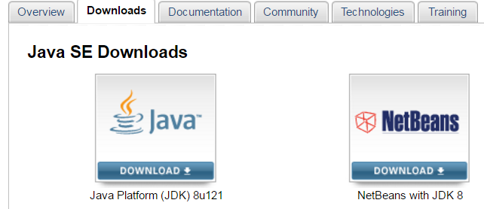

b. So you can click on the ‘Java Download’ icon. In this case we are downloading JDK 8.

c. You will be redirected to a page from where you can download your latest version JDK.

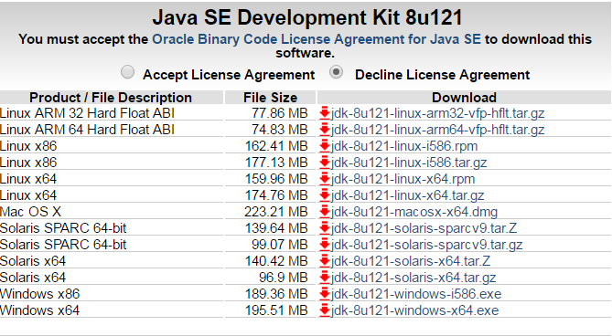

But first you need to determine how many bits is your operating system. This can be done by just right clicking on ‘My Computer’ and clicking on ‘Properties’.

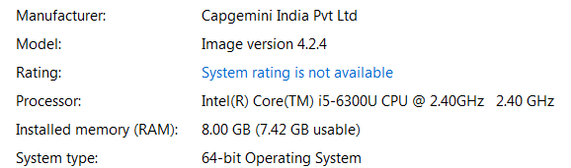

So in this case it is 64-bit operating system.

d. So in the JDK download page first click on ‘Accept License Agreement’ and then click on ‘jdk-8u121-windows-x64.exe’. So the executable file gets downloaded.

e. Install JDK using the executable file.

f. After installing JDK we need to set the environment variables as show below:

JAVA_HOME = C:\Program Files\Java\ jdk1.8.0_101

Path =…..; %JAVA_HOME%\bin;

g. After configuring the environment variables open command prompt and type the command ‘java –version’: 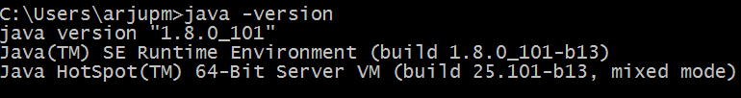

If you get the above result, your JDK is successfully installed.

Note: For Anypoint Studio IDE we need to have a JDK version 1.7 or higher.

1. Maven Setup

Please follow the below steps for installing maven on your machine:

1. Maven is a java based tool, so we need to first verify whether JDK 1.5 or above version is installed in our machine. So for JDK installation you can go through the previous section ‘Java Development Kit Setup’.
2. Download the latest version of Maven from <http://maven.apache.org/download.cgi>.

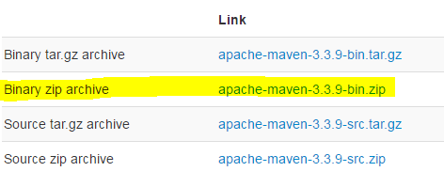

1. Extract the archive, to the directory you wish to install Maven 3.3.9. The subdirectory apache-maven-3.3.9 will be created from the archive.

C:\Program Files\Apache Software Foundation\apache-maven-3.3.9

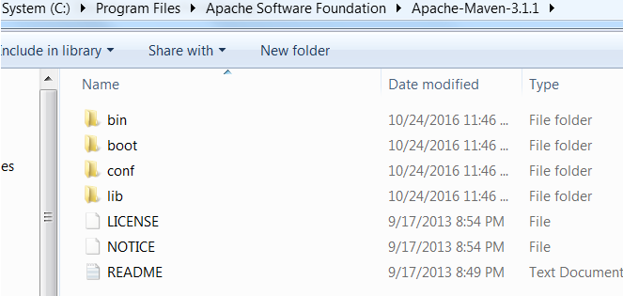

1. Next we need to set maven environment variables. You can go to ‘My Computer’-> properties-> Advanced System Settings -> Environment Variables.

M2_HOME=C:\Program Files\Apache Software Foundation\apache-maven-3.3.3

M2=%M2_HOME%\bin

MAVEN_OPTS=- -Xms256m -Xmx512m -XX:MaxPermSize=256m

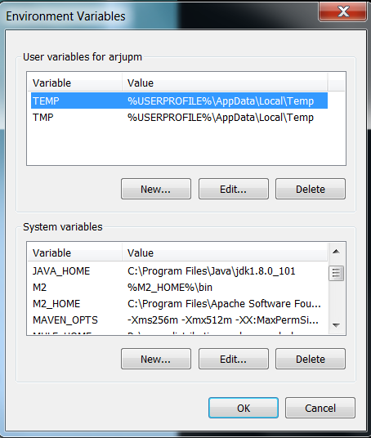

1. Now you can append the M2 variable to system path.

Path =…..; %M2%\bin;

1. To verify maven has been successfully downloaded open command prompt and type the command mvn --version:

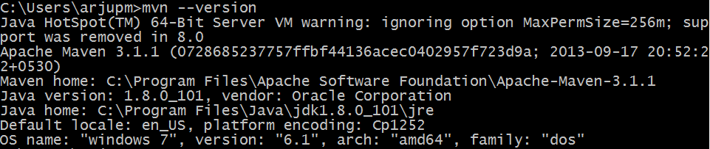

If you get the above output, then maven has been successfully installed.